**About My Self**

***I'm a computer science Engineering B.tech(AI & Ml) Student at college of Barasat, Brainware University. I love to explore the possibilities of connecting people through technology.***

***Computer science + tech = a happy world. I design, create and teach with technology to make the world a better place.***

***I want to be a best learner in an Mern stack developer... and made my self a best coder with my skills.***

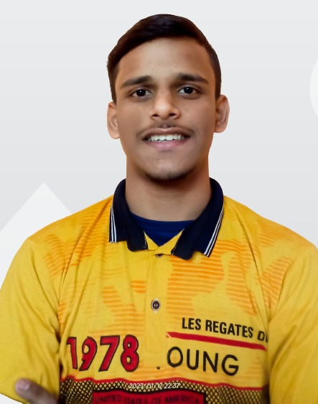



**9831088911**

**prakashhalwai59@gmail.com**

**63 west KamalaGouri apartment 2**

**SKILLS**

*SKILLS*

**TECHNICAL QUALIFICATION – 3 YEARS DIPLOMA ENGINEERING**

|  |  |  |  |  |  |  |  |  |  |  |
| --- | --- | --- | --- | --- | --- | --- | --- | --- | --- | --- |
| *Institute* | *Discipline /*  *Stream in*  *Engineering* | *Council* | *3 year diploma engineering semester wise break –*  *Up % Mark’s* | | | | | | | *Year of*  *Passing*  *out* |
| **Technique**  **Polytechnic**  **Institute**  **Hooghly**  **West Bengal** | **Diploma** in  **Computer Science**  **And technology** | **West Bengal state council of technical**  **And vocational**  **Education and skills development** | 1st  Sem | 2nd  sem | 3rd  sem | 4th  Sem | 5th  Sem | 6th  Sem | **average %**  **upto the**  **last semester** | **2023** |
|  |  | **84.9** | 76.0 | 76.9 | 80.0 | 79.0 |

|  |  |  |  |  |  |
| --- | --- | --- | --- | --- | --- |
| ***Exam*** | ***Institution*** | ***Board*** | ***Subject taken*** | ***% of***  ***Mark’s*** | ***Year of***  ***Passing*** |
| *Class X* | **Rishra high school**  **(H.S)** | **WBBSE** | **Bengali , English , History ,**  **Geography , Physical Science , life Science , Math** | **47.9%** | **2019** |
| *Class Xii/*  *ITI/ vocational* | **Rishra high school**  **(H.S)** | **WBCHSE** | **BEN2 , ENG2 ,CMNT ,WPDV**  **MTH2 , PHYS , CHEM , ENST** | **61.0%** | **2021** |

* **PC MAINTENANCE AND**

**COMPUTER NETWORKING**

**Place:- Technique polytechnic institute**

**Duration :- 72 hours .**

* **CISCO CYBER SECURITY .**

**Places:- Remotely .**

**Duration :- 42 hours**

* **MERN STACK WEBDEVELOPMENT**

**USING HTML CSS JS NODEJS MONGODB**

**From TOPSTACK INDIA PVT.LTD**

**Places:- Remotely.**

**Duration: 80 hours.**

* **Amazone Web Service (AWS)**

**From D.H Technology**

**Date:-12/1/2024 – 8/7/2024**

**Training /Internship**

* **Programming Language** – C, JAVA, HTML

**CSS, JAVA SCRIPT, NODEJS, MONGODB**.

* **Operating System** – Windows
* **Tools** – DEV C++, VS CODE , ESCLIPS,
* **Databases** –MONGODB
* **Programming Language** – C, JAVA, JAVA SCRIPT.
* **Operating System** – Windows
* **Tools** – DEV C++,VS CODE , PYCHAM, ESCLIPS, MY SQL WORKBENCH.
* **Databases** –MySQL.

**LANGUAGES**

***LANGUAGES***

* **BENGALI (Fluent)**
* **English (conversational )**
* **HINDI (conversational)**
* **BENGALI (Fluent)**
* **English (conversational )**
* **HINDI (conversational)**

**HOBBIES**

***HOBBIES***

* **Swimming**
* **Art and crafts**
* **Swimming**
* **Reading Book’s**
* **Art and crafts**
* **Music.**

**Date of birth :16/12/2002 Gender :- Male.**

**Height :-5.5ft. weight :-56 kg.**

**Guardians name:- Chandi Halwai. Guardian’s Occupation :-Shop Owner.**

**Aaadhaar No :-6357 0297 0666 Pan:- BNEPH8684R.**

**Personal Details**

**General Qualification—class x and class xii**